Name: ___________________________________ Date: _____________________ Period: ______

1. Which of the following statements best describes how the First Amendment affects religion in the United States?

a. The government has an official religion.

b. There can be no religion in the United States.

c. Religion cannot be dictated religion.

d. State employees cannot have a religion.

2. Use the quotation to answer the question.

*“The enumeration in the Constitution, of certain rights, shall not be construed to deny or disparage others retained by the people.”*

—excerpt from the U.S. Constitution, Amendment IX

Which statement most accurately explains the significance of the excerpt?

a. Even though the Constitution only grants certain rights, other rights shall not be denied

b. Congress must approve any rights not listed in the Constitution before they are granted to the people.

c. People have only the rights granted in the Constitution.

d. People have only the rights granted in the Ninth Amendment.

3. Rights such as those in the First Amendment fulfill which purpose of government?

a. to help people cooperate

b. to limit rights of individuals

c. to provide services

d. to guarantee freedoms

4. Which of the following best describes the purpose of the Bill of Rights?

a. to explain the procedure for amending the Constitution

b. to inspire the governments of other nations

c. to guarantee freedoms that belong to every citizen

d. to limit the rights of individual citizens

5. Which amendment to the Constitution might the U.S. Supreme Court have relied on when it struck down the death penalty for minors?

a. First Amendment

b. Fifth Amendment

c. Eighth Amendment

d. Ninth Amendment

6. Which amendment protects Americans from unreasonable searches and seizures?

a. First Amendment

b. Fourth Amendment

c. Sixth Amendment

d. Thirteenth Amendment

7. The First Amendment protects freedom of speech, but there are some limits to free-speech rights.

Why are some forms of speech not protected?

a. because others could be physically harmed by them

b. because they are expressed in writing

c. because they criticize the government

d. because they support different religious views

8. How does the Fifth Amendment protect an individual’s right to own property?

a. by preventing the government from taking private property without fair payment

b. by guaranteeing every citizen the right to apply for a home loan

c. by preventing a police search of private property without a warrant

d. by prohibiting the quartering of soldiers without permission

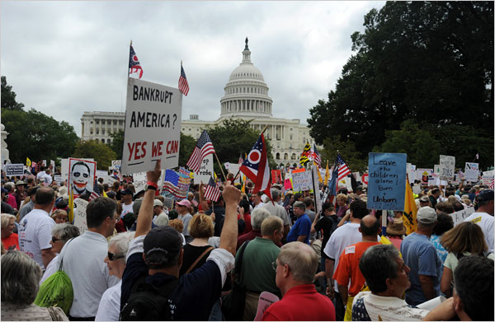

9. What First Amendment right are the people in this photograph expressing?

a. freedom of the press

b. freedom of religion

c. freedom of assembly

d. right to privacy

10. Use the quotation to answer the question.

*“In all criminal prosecutions, the accused shall enjoy the right to a speedy and public trial, by an impartial jury. ”*

—excerpt from the U.S. Constitution

Which amendment is this quotation from?

a. First Amendment

b. Fourth Amendment

c. Sixth Amendment

d. Thirteenth Amendment

11. How do the Ninth and Tenth amendments limit the power of the federal government?

a. by listing specific rights that belong to the states

b. by reserving rights not granted to the federal government for the states and people

c. by listing specific rights that belong to the people

d. by preventing the federal government from changing the Constitution

12. Use the quotation to answer the question.

*“Congress shall make no law respecting an establishment of religion, or prohibiting the free exercise thereof; or abridging the freedom of speech, or of the press; or the right of the people peaceably to assemble, and to petition the Government for a redress of grievances.”*

—excerpt from the U.S. Constitution

Which amendment is this quotation from?

a. First Amendment

b. Fourth Amendment

c. Sixth Amendment

d. Thirteenth Amendment

13. Which of the following is a limitation of the First Amendment’s guarantee of the right to freedom of speech?

a. People may not tell lies that might harm another person’s financial reputation.

b. People may not criticize the actions of their neighbors.

c. People may not criticize the government.

d. People may not deliver a speech in public.

Answer Key:

1. c
2. a
3. d
4. c
5. c
6. b
7. a
8. a
9. c
10. c
11. b
12. a
13. a